ASSESSMENT OF MARGINAL WORKERS IN TAMILNADU

Problem Definition:

The project at hand entails an in-depth analysis of the demographic characteristics of marginal workers in the Tamil Nadu region, with a specific focus on their age, industrial categories, and sex. The primary objective is to conduct a comprehensive socioeconomic analysis and create visual representations that vividly depict the distribution of marginal workers across various categories. This project mandates the formulation of clear objectives, the establishment of an effective analysis approach, the selection of appropriate visualization techniques, and the actual execution of the analysis using Python and data visualization libraries.

Design Thinking:

Project Objectives:

Demographic Analysis: The primary objective is to gain a deep understanding of the demographic profile of marginal workers in Tamil Nadu. This includes assessing their age distribution, gender representation, and the prevalence of different industrial categories.

Age and Gender Distribution: To analyze and visualize the age distribution of marginal workers, with a focus on identifying any significant age groups. Similarly, to examine the gender distribution among these workers.

Industrial Categories: Investigate and represent the distribution of marginal workers across various industrial categories in Tamil Nadu, identifying sectors with significant worker presence.

Analysis Approach:

Data Collection: Gather relevant datasets containing demographic information of marginal workers in Tamil Nadu. Ensure data quality and cleanliness.

Data Preprocessing: Clean and preprocess the dataset to handle missing values, outliers, and inconsistencies.

Descriptive Statistics: Compute basic descriptive statistics to understand the central tendencies, spreads, and distributions of age, gender, and industrial categories.

Visualization: Utilize Python's data visualization libraries (e.g., Matplotlib, Seaborn) to create visually compelling representations of the data. For age distribution, a histogram or box plot could be suitable, while a pie chart or bar chart might work well for gender and industrial category distribution.

Inferential Statistics: Apply statistical tests, if needed, to draw meaningful insights from the data, such as identifying statistically significant age groups or gender imbalances.

Insights and Recommendations: Summarize the findings and draw actionable insights from the analysis, which can inform policies or programs aimed at assisting marginal workers in Tamil Nadu.

Visualization Selection:

Age Distribution: A histogram or a box plot would effectively illustrate the age distribution of marginal workers, highlighting any concentration of workers in specific age groups.

Gender Distribution: A pie chart or a bar chart can be used to represent the gender distribution, providing a clear visual of the ratio of male, female, and other genders among marginal workers.

Industrial Categories: A grouped bar chart or a stacked bar chart could visually present the distribution of marginal workers across different industrial categories, making it easy to identify dominant sectors.

The chosen visualization types will be selected based on their ability to convey the data insights effectively and intuitively. Regular review and feedback from stakeholders will be integrated into the design and analysis process to ensure that the project aligns with the objectives and meets the needs of the intended audience.
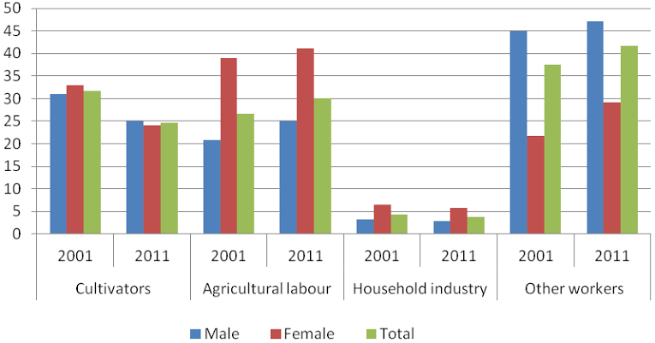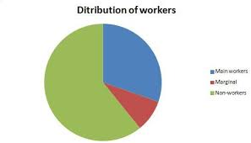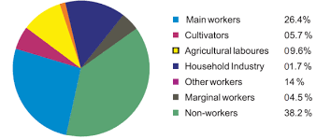

conclusion:
The analysis of the demographic characteristics of marginal workers in Tamil Nadu provides valuable insights that can guide the development of policies and initiatives aimed at improving their socio-economic conditions. It underscores the importance of considering age, gender, and industrial category as key factors when designing interventions to address the unique needs of this vulnerable population.

